Washington Legislative District 22 – Precinct Voting Analysis
Data: Thurston County Election Archive – Results by Precinct (2022, 2024)
Purpose:
This analysis is designed to identify moderate and persuadable precincts within Washington Legislative District 22.
Based on prior election results, the current incumbent won approximately 61% of the vote, while the conservative candidate received roughly 38%. This indicates the district leans Democratic overall.
Because the campaign is not positioned to win the far-left vote, winning the election depends on “carrying the middle” on both sides.

The goal of this analysis is to determine which precincts best represent the political middle (“moderate” precincts) and offer the highest ROI for campaign investment.

District-Level Results Overview (Baseline Context)

Let’s look at what happened in the last 2 elections, to set a baseline to identify persuadable precincts:
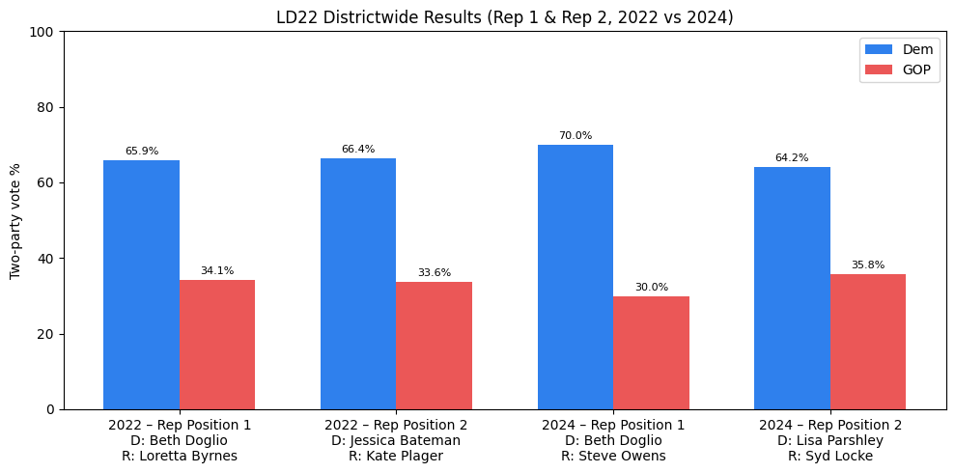
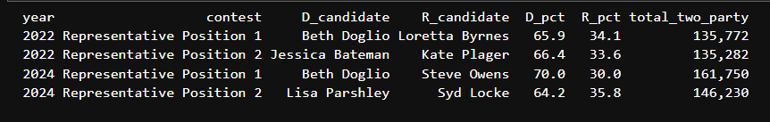

Districtwide election results show that LD22 remains solidly Democratic. Between 2022 and 2024, Democratic performance diverged by seat: Representative Position 1 moved sharply left, with the incumbent increasing her margin despite significantly higher turnout, while Representative Position 2 moved modestly right, with the Republican share increasing slightly.

To understand precinct level campaign opportunities, we’ll use the average district results.

Identifying “High-Opportunity” Precincts

To identify precincts that are more likely to be persuadable, we used a simple scoring method based on 4 signals drawn from practical precinct-level election analysis practices. We identified these via research using AI (ChatGPT Deep Research), and further online research on the topic.

Important note: These signals do not prove a precinct is ideologically “moderate.” They indicate places where support is less locked-in, where results are closer, or where voters show proclivity to specific candidates rather than party—all of which can correspond to higher persuasion potential.

- Electoral Closeness (Weight: ×2.0)
Closeness captures how competitive recent races have been within a precinct, measured as the average top-two margin across Position 1 and Position 2 contests. Tighter margins indicate the presence of persuadable voters. For example, a 10-point margin signals substantially more opportunity than a 40-point blowout.

- Incumbent Weakness (Weight: ×1.5)
This factor measures changes in incumbent performance between 2022 and 2024. If the incumbent (Doglio) lost vote share over time, it suggests erosion of support and openness to an alternative candidate. A negative swing is treated as an opportunity signal; for instance, a 5-point decline contributes positively to the overall score after weighting. We’re only looking at 2 years of election data – so this doesn’t necessarily indicate a deep trend, but makes the best use of the data we have.

- Turnout Level (Weight: ×0.5)
Turnout reflects the level of voter engagement (ballots cast / registered voters) in a precinct. Higher-turnout precincts are prioritized because they likely contain voters who are more likely to participate when contacted. Turnout is normalized to a 0–15 scale and receives a moderate weight, acknowledging its importance while avoiding over-penalizing lower-turnout areas that may still be competitive.

- Precinct Size (Weight: ×0.5)
Size accounts for the total number of voters in a precinct (registered voters). Larger precincts offer more votes per dollar spent on outreach, increasing campaign efficiency. This factor includes a capped bonus (maximum of 10 points) to prevent very large precincts from overwhelming other indicators.

Factor | Weight | Logic
Closeness | ×2.0 | Tight margins (Pos 1 + Pos 2 avg) mean persuadable voters exist. A 10-pt margin scores higher than a 40-pt blowout.
Incumbent Weakness | ×1.5 | If Doglio lost ground from 2022→2024, voters are open to change. A -5 pt swing = +7.5 to the score.
Turnout | ×0.5 | Higher turnout = more engaged electorate worth targeting. Normalized 0–15 scale.
Size | ×0.5 | Larger precincts offer more voters per dollar spent. Bonus capped at 10 pts.

Precinct Rankings and Analysis Results

Here’s the top 5 “high opportunity” precincts based on our algorithm:
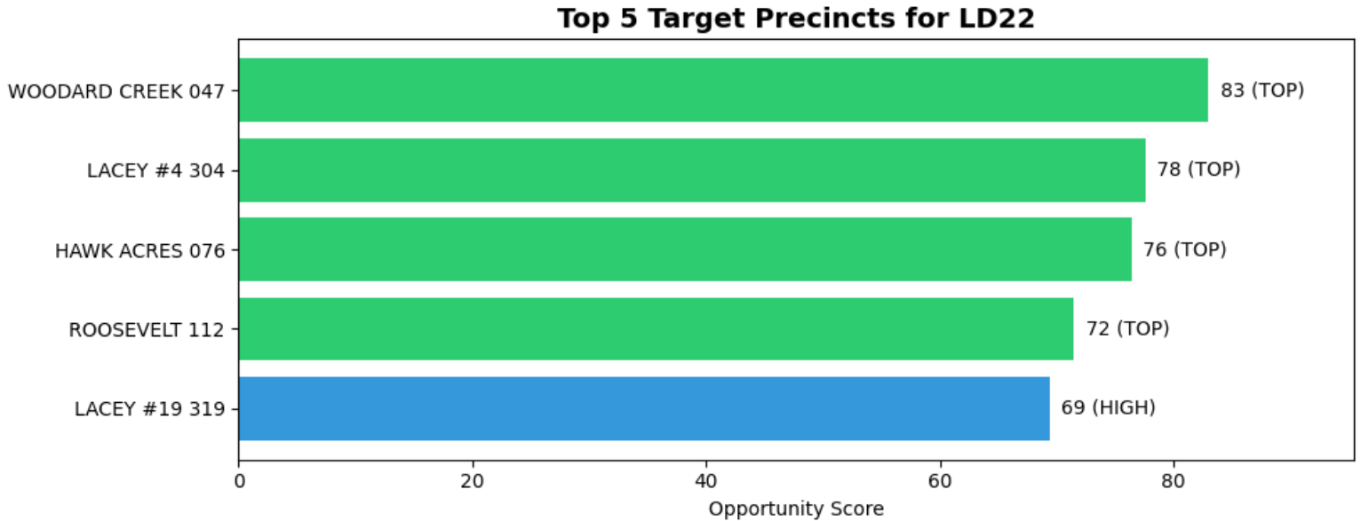

To understand how to interpret the chart – let’s look at the data for our top precinct, Woodard Creek 047.

- Competitive margins: Both recent races (2022, 2024) were decided by 10–20 points (not a landslide)
- No incumbent momentum: Doglio’s support is essentially flat (–0.5 pts from 2022 to 2024). Voters are not consolidating around the incumbent, leaving room for a challenger.
- Very high turnout: Turnout scored an 83, meaning voters here reliably show up. Outreach is far more likely to convert into actual votes.
- Meaningful size: 538 ballots cast
For the full dataset – including all columns + the raw source data. See the attached .csv files.

Please let me know if you have any questions!

